THE HISTORY OF THE BRITISH PEOPLE

(Sabine Heinrich)

Kontakt: sabine.heinrich@kpr.at

Schulstufe: sek. Stufe 2

Fach: Englisch, Geschichte

Inhalt/Lehrziel: Großbrittanien

CHAPTER ONE

THE HISTORY OF THE BRITISH PEOPLE
One spring Genia, while staying in London for a school-trip, visits the British Museum, Britain’s most popular tourist attraction in the heart of London. Here she has to explore the history of the British people and their language. She will have to write an essay on those topics later.
On the way from the cloakroom to the exhibition she gets lost and bumps into a strange looking man wearing very old-fashioned clothes.

Genia: | Excuse me, Sir.  I’ve got lost in those corridors.  Can you show me  the way to the Prehistoric and  Romano-British collections?  I guess  they are on the first floor. | 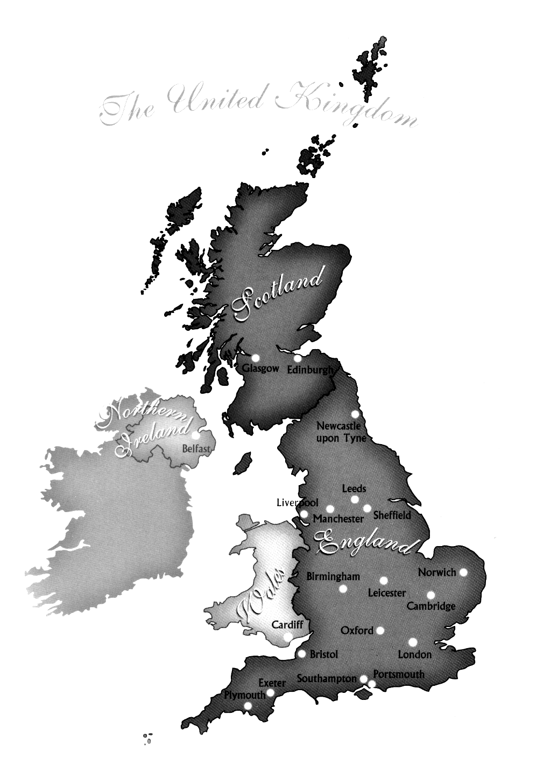
William: | Yes, of course, my dear.  Just follow me.  You’re not English, are you?
Genia: | No, I’m not.  I come from Austria.  I’m spending three weeks in London  doing a language course and  today I have to find out more  about the history of the British people  and their language.
William: | Well, then you’re in the right place because  the British Museum is not only famous  for its large collections of  Egyptian, Greek and Roman art  but it also contains treasures  from Anglo-Saxon and Celtic Britain.  Shall I lead you around and  tell you more about the British people? |  |  | 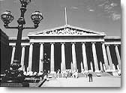  THE BRITISH MUSEUM
Genia: | This would be very kind of you.
William: | Good, then let’s start with introducing myself.  I’m  William the Conquerer.  Before I came to England in 1066  people had already lived there  for many thousand years. |  | William the Conquerer (1027-87),  Duke of Normandy. He became king of England after defeating King Harold at the Battle of Hastings in 1066.  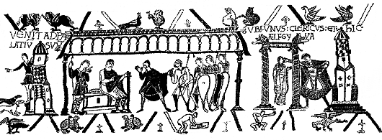
Genia: | How do we know that?
William: | The earliest human bones found in England  have been dated 200,000 years old.  The first groups of people on the British Isles  were  Palaeolithic nomads  from mainland Europe.  They hunted large wild animals and  travelled to Britain by land and sea. |  | 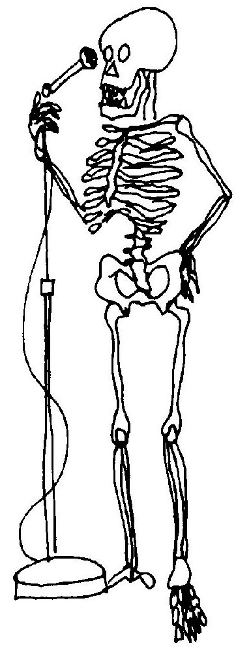  Palaeolithic = Old Stone Age  At those times the country  was still joined  to the European land mass.
Genia: | Was it then that the famous Stonehenge was built?
William:  Genia: | No, it was built much later,  in the  Neolithic period  between 3050 and 2300 BC.  It is one of the most famous and  mysterious archaeological sites in the world.  One of its mysteries is  how it was ever built at all  with the technology of the time.  The stones come from over 200 miles away  from Wales.  What was it used for? |  | Neolithic = New Stone Age  BC = before Christ
William:  Genia: |  |  | 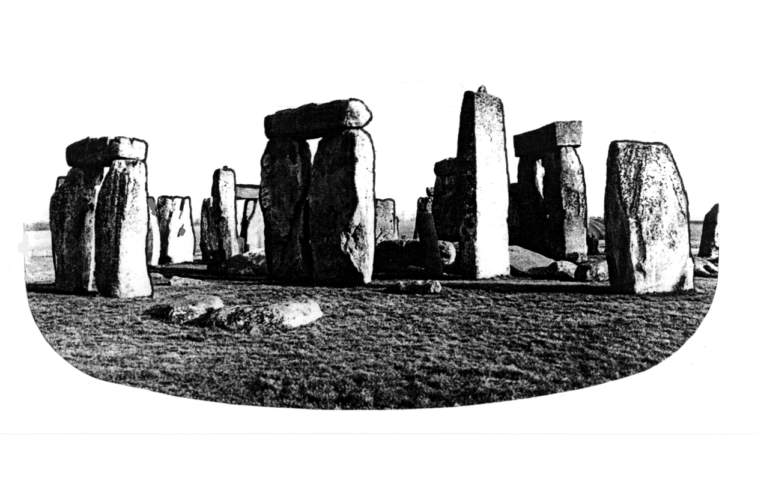
William:  Genia: | We know it was used by the druids  for ceremonies and it appears  to function as a kind of astronomical clock.  Do you also know something about the Celts?  I particularly like Celtic music. |  | druid = a member of the ancient Celtic priesthood  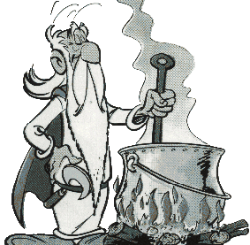
William: | Between 800 and 200 BC  there was a large and peaceful  Celtic movement  into Britain from mainland Europe.  The Celts brought an Iron Age civilization with them. |  | 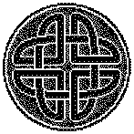  The Iron Age
William: | From 55 BC the Celts were driven  to the border regions of the British Isles  when the  Romans  invaded the country. |  | 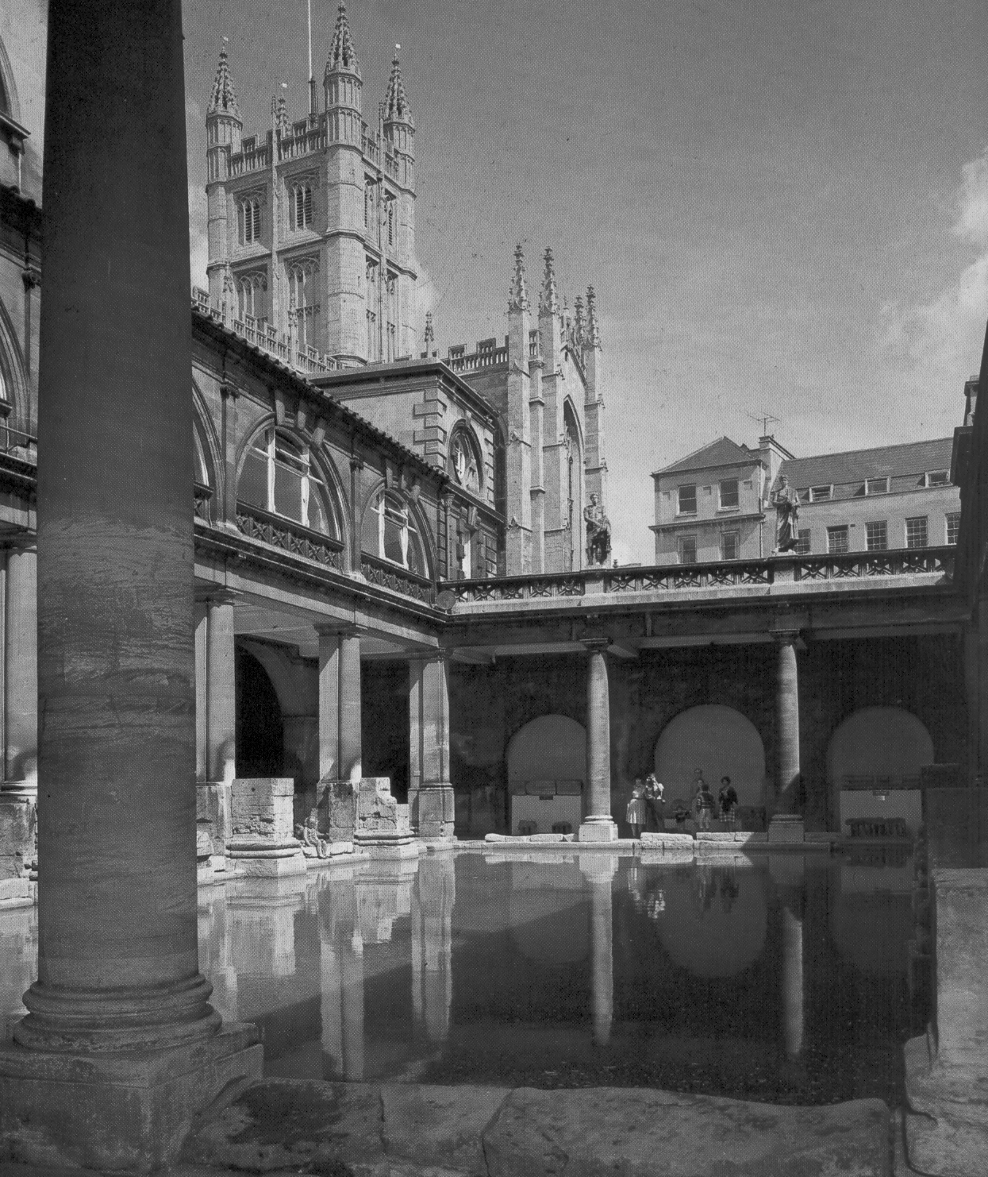  The Roman Bath
Genia: | Where in Britain can I find Roman buildings?
William: | A fine example of Roman architecture  is the Roman baths in Bath  in the west of England.
 | If you travel north,  you’ll come across Hadrian’s Wall,  running along the border between present-day  England and Scotland.  Hadrian’s Wall was built by the Romans  in the second century  to protect their territory  from attacks by the Scots and the Picts. |  | 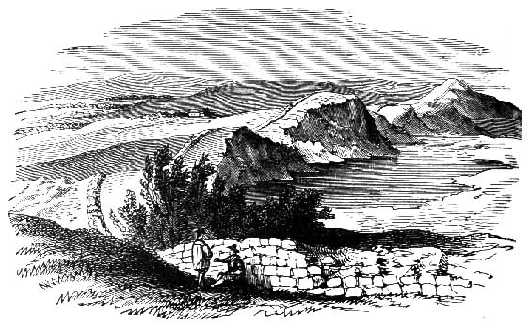
Genia: | Did the Romans stay in England for long?
William: | The Roman occupation of Britain  lasted for some 360 years.  In AD 410 the  Germanic tribes  of the Angles and Saxons,  who came from north-eastern Europe,  arrived.  Celtic areas remained  in Wales, Scotland and Ireland.  All these regions suffered from  the  Vikings,  who invaded the country  in the 8th and 9th century. |  | GERMANIC TRIBES:  Angles  Saxons  Jutes  AD = anno domini  in the year of the Lord  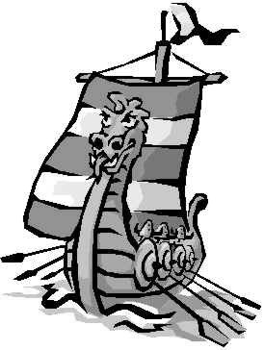
Genia: | And then you entered the stage.
William: | Well remembered!  In 1066 I came to England  from Normandy with my army and  we defeated the Anglo-Saxons in the  Battle of Hastings.  The period following this battle  is also called the  Norman Conquest.  This was the last successful  foreign military invasion  of the country.  But Celtic civilizations continued in most of  Wales, Scotland and Ireland. |  | 1066: Battle of Hastings  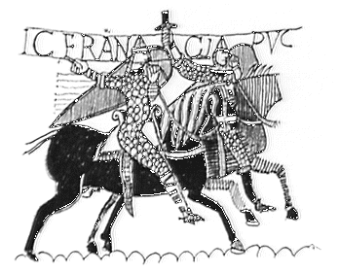
Genia: | How did Great Britain come to be?
William: | After 1066  there were many political and  military attempts to unite  England, Wales, Scotland and Ireland.  While England, Wales and Scotland  had become Protestant,  Ireland remained Catholic  and tried to distance itself from England.  Ireland was first attacked in the 12th century.  Wales lost its independence in 1285 and  Scotland remained independent until 1707,  when the creation of Great Britain took place. |  | Great Britain =  England, Wales, Scotland, Ireland  United Kingdom =  Great Britain and Northern Ireland
Genia: | And what about the United Kingdom?
William: | The UK was established between  Great Britain and Ireland in 1800.  The  Union Jack,  the flag of Britain,  is made of the flags of the three countries. |  | 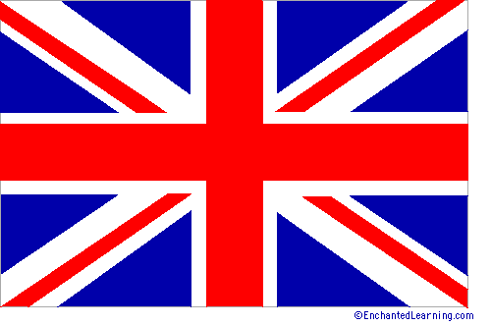 The Union Flag  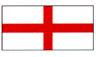 The red cross of Saint George, for England, on a white ground.  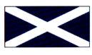 The white diagonal cross of Saint Andrew, for Scotland, on a blue ground.  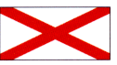The red diagonal cross of Saint Patrick, for Ireland, on a white ground.  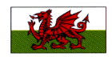Wales is not represented in the Union Flag.
Genia: | Did other groups of people  come to Britain  after the Norman Conquest?
William: | Over the centuries  there was a steady peaceful immigration  from abroad.  Not only was there migration  within the British Isles  but newcomers also arrived  from overseas,  e. g. gypsies, blacks, Jews.  In the 16th and 17th century  there was a great number of refugees,  such as Dutch Protestants and French Huguenots.  By the end of the 17th century  5.5 million people  lived in England and Wales  and about 1 million in Scotland.  Immigrants contributed to major changes  in agriculture and industry.  Many of the newcomers  were encouraged to settle in Britain  but they had no legal rights and  could be easily expelled. |  | migration = travelling so as to change  one’s place of living  immigration = the process of entering  another country to  make one’s life and home  there  At the end of the 17th century →  5.5 million people in England and Wales  1 million in Scotland  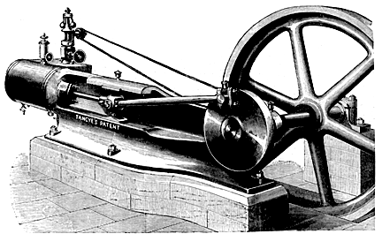
Genia: | Weren’t there many people  who came to Britain  during the Industrial Revolution?
William: | Yes, there were.  The population increased rapidly  so that by the end of the 19th century  30 million people lived in England and Wales  as Britain was the world’s leading industrial nation. |  | At the end of the 19th century →  30 million people in England and Wales  Britain =  leading industrial nation
Genia: | I know from my grandma  that during World War II  thousands of people from Austria  went to live in Britain.
William:  William: | That’s true.  Although there were legal restrictions  concerning immigration,  lots of refugees and immigrants  arrived in Britain  as a result of the 1930s world recession  and the Second World War.  Also from the late 1940s onwards  considerable numbers of coloured immigrants  from the countries of the Commonwealth,  such as India, Pakistan or the West Indies,  settled in Britain.  From the early 1960s  there were laws to restrict  the number of immigrants. |  | refugee = someone who has been  forced to leave their country  for political reasons or  during a war  Commonwealth of Nations =  an organization of about 50 independent states, which were formerly part of the British Empire.  The Queen is the head of the Commonwealth. Famous members: Canada, Australia, New Zealand, India.
Genia: | So, how would you describe a typical Brit?
William: | It’s difficult  to describe a typical Brit  because the Scots, Welsh and Irish  regard themselves as largely Celtic,  while the English  are mainly Anglo-Saxon in origin.  There has been a degree  of  racial and cultural intermixture  over the centuries and  internal migration  between the four nations. |  | 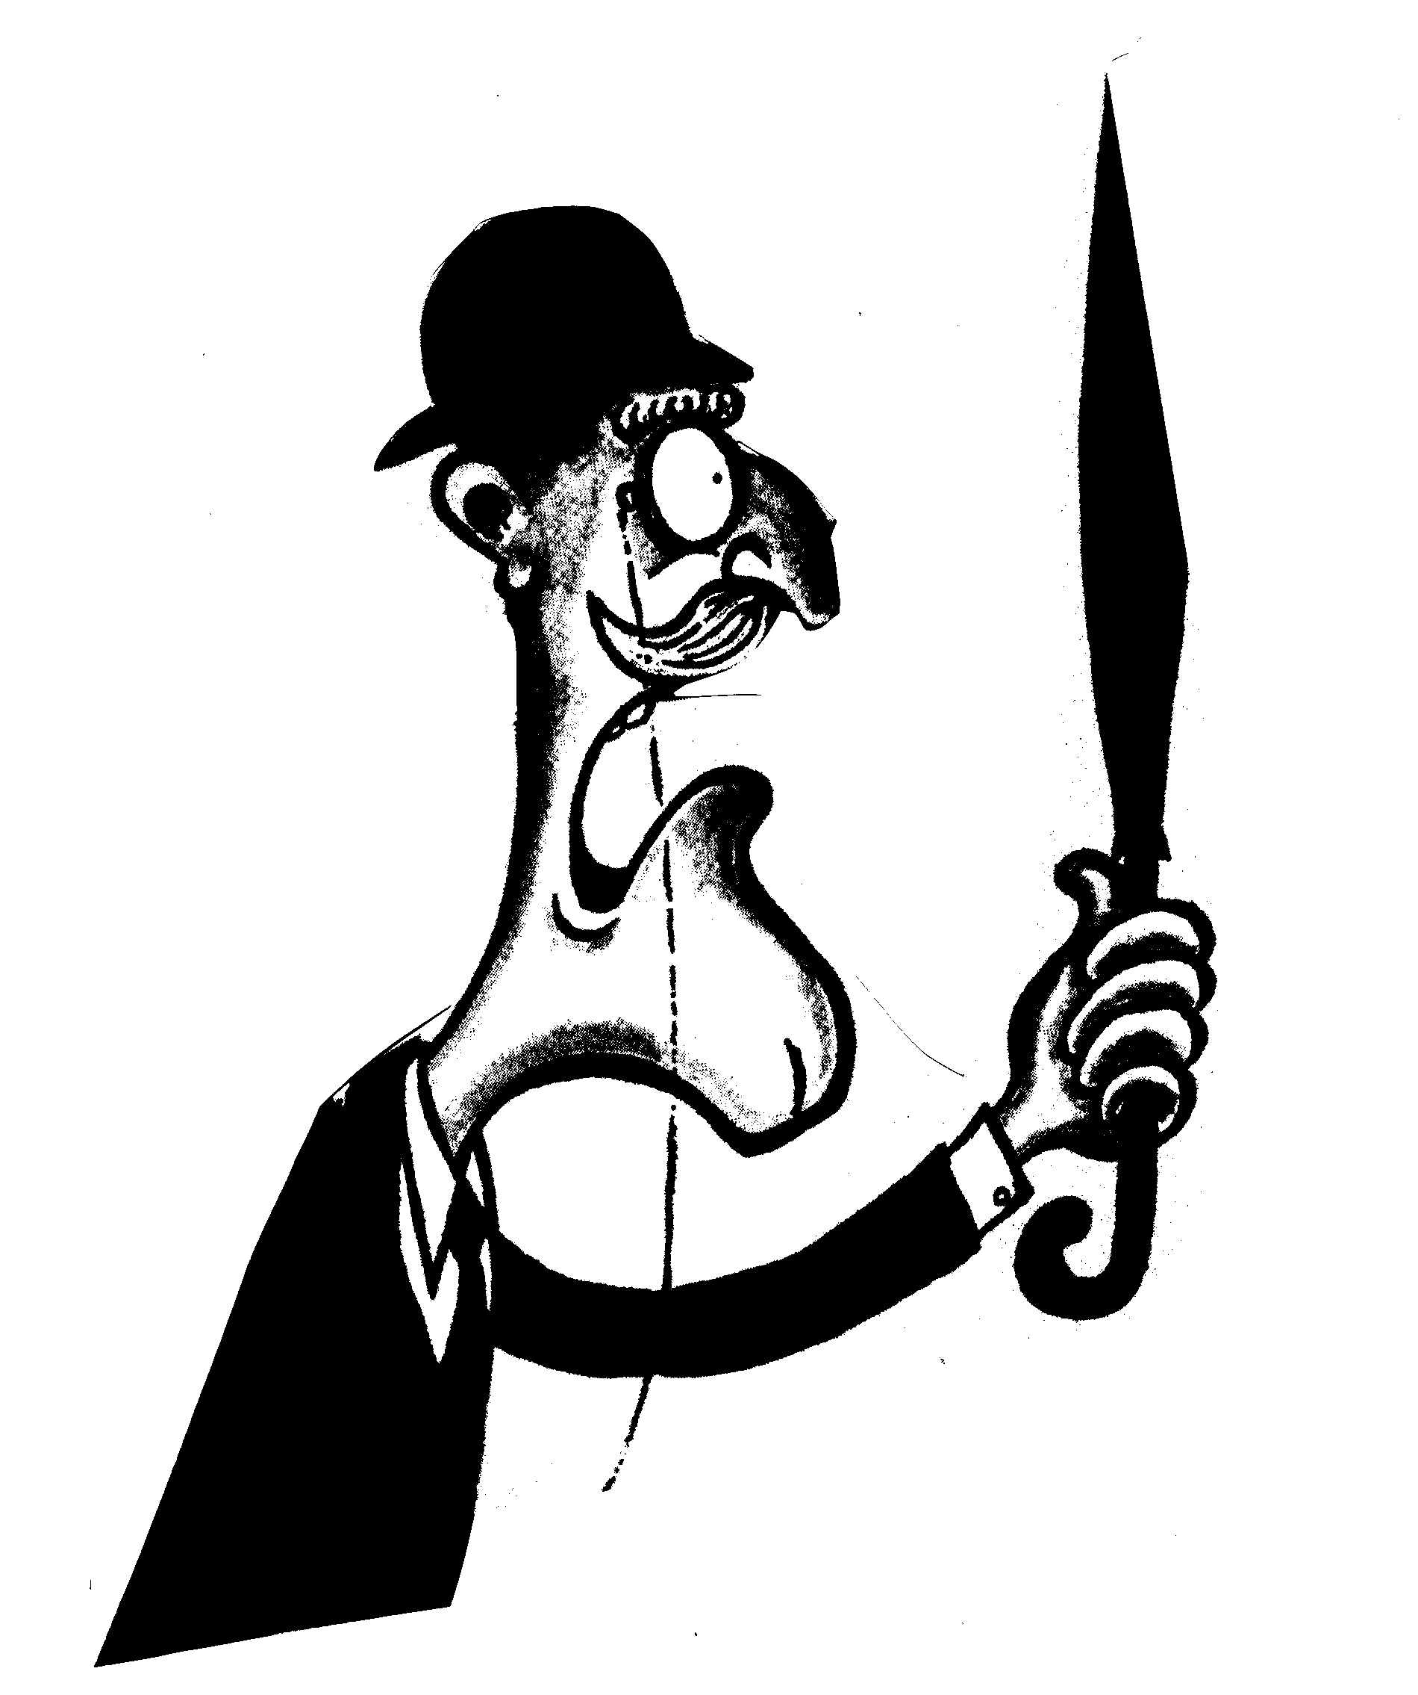  A typical Brit?
Genia: | Do Wales, Scotland and Northern Ireland  have their own languages?
Will: | Well, I’m not exactly  The English language  an expert on languages.  Perhaps you should meet  my friend Samuel Johnson  in the British Library.
Genia: | This journey through British history  was very fascinating.  Thanks a lot.  Good bye.
Will: | Thank you.  You better take the tube  to King’s Cross now  because the Library closes at 6 pm.  You’ll find Sam  dusting the dictionaries  in the King’s Library.  Send him my regards.  Good luck and good bye. |  |   KING’S CROSS

